Deploy ASP.NET Core API to Azure App Service Using Visual Studio
Complete Hands-On Deployment Guide
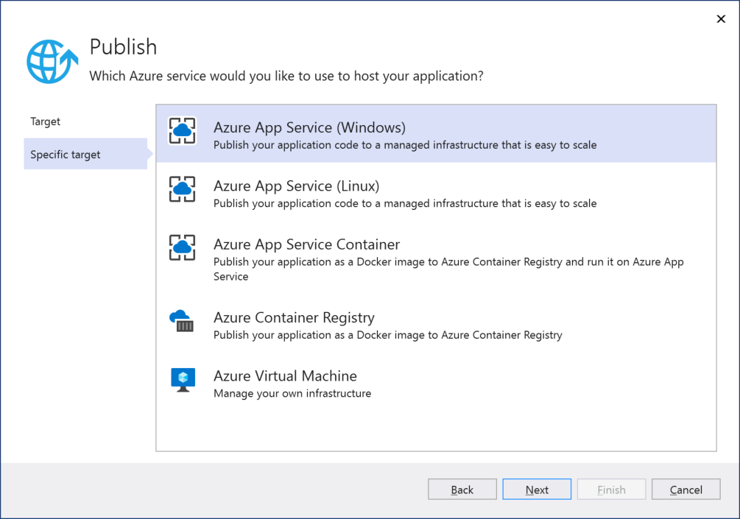
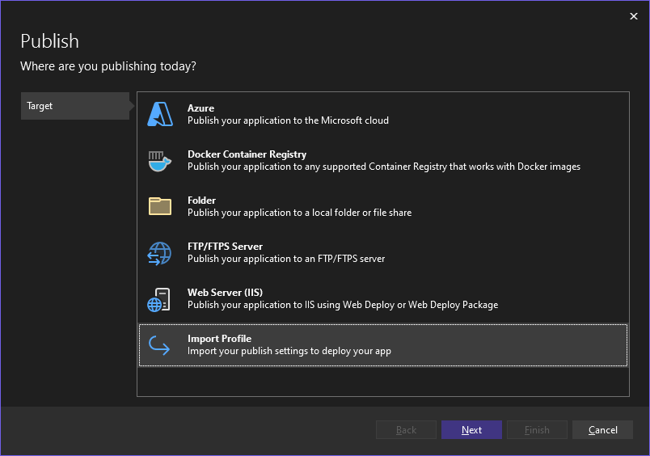
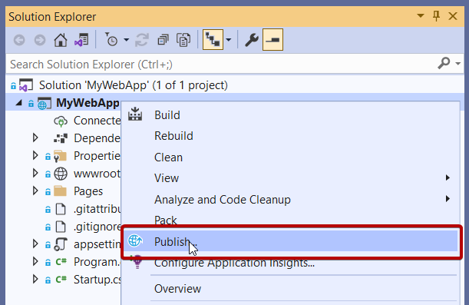
6
This guide assumes:
- You have Visual Studio 2022+
- Your ASP.NET Core API project is ready
- You are signed in with your Azure account in Visual Studio

1. Open Your ASP.NET Core API Project
- Launch Visual Studio
- Open your .sln project
- Ensure your project builds successfully
  - Build → Build Solution

2. Right-Click the Project → Publish
- In Solution Explorer
- Right-click your API project
- Select Publish
Visual Studio will open the Publish wizard.

3. Choose “Azure” as the Publish Target
You will see publishing options like:
- Folder
- Azure
- IIS
- Docker, etc.
Choose:
Azure → Azure App Service (Windows)
(or Azure App Service (Linux) based on your hosting plan)
Click Next.

4. Select the Existing App Service
Visual Studio will now show your Azure subscription resources.
Steps:
- Select your Subscription
- Select the Resource Group that has your App Service
- You will see your previously created App Service
- Select it
- Click Next
- Click Finish
This binds Visual Studio to your cloud App Service.

5. Configure Publish Settings (Optional but Recommended)
Click Edit beside the publish profile.
You will see:
- Configuration → Release
- Target Framework
- Deployment Mode → Framework-Dependent / Self-Contained
- File Publish Options
  - Delete existing files
  - Produce single file (optional)
Keep defaults unless you have specific requirements.
Click Save.

6. Publish the Application
Press Publish.
Visual Studio will:
- Build the project
- Package the application
- Upload the deployment bundle to Azure App Service
- Restart the App Service
- Show logs in the output window
After deployment, Visual Studio opens your URL automatically, for example:
https://yourappname.azurewebsites.net/swagger

7. Test Your API (Swagger)
If your API uses Swagger/OpenAPI:
- Open browser
- Navigate to your App URL with /swagger
Example:
https://myapidemoproject.azurewebsites.net/swagger
Confirm:
- Endpoints appear
- You can call GET/POST methods successfully

8. Configure App Settings & Connection Strings in Azure (If Needed)
In Azure Portal:
- Go to your App Service
- Select Configuration
- Go to:
  - Application Settings
  - Connection Strings
Examples:
- ConnectionStrings:DefaultConnection
- ASPNETCORE_ENVIRONMENT
- API keys
Click Save → Azure will restart the app automatically.

9. Check Logs (Important for Debugging)
In Azure Portal:
- App Service → Log Stream
- Observe live logs:
  - Startup errors
  - Connection failures
  - Exceptions
Useful when debugging deployment issues.

10. Enable Continuous Deployment (Optional)
If you want auto deployment whenever you push code:
- Use GitHub Actions
- Use Azure DevOps Pipelines
I can give a full CI/CD guide if needed.

Summary Table
Step | Action
1 | Build API project
2 | Right-click → Publish
3 | Choose Azure App Service
4 | Select existing App Service
5 | Configure publish profile
6 | Publish from Visual Studio
7 | Test via Swagger
8 | Configure App Settings
9 | Use Log Stream for debugging

